**TWAHIRAH ISLAMIC DAY & BOARDING PRIMARY SCHOOL**

**PRE-PLE SET 1 – 2024**

**INTEGRATED SCIENCE**

Time allowed: 2hrs 15 minutes

NAME: ……………………………………………………………………………………………….………………………

District name:……………………………………………………………………………………………………………

|  |  |  |  |  |  |  |  |  |  |
| --- | --- | --- | --- | --- | --- | --- | --- | --- | --- |
|  |  |  |  |  |  |  |  |  |  |

INDEX NUMBER:

***SECTION A***

1. Which substance exists in all the three states of matter?

_______________________________________________________

2. Name the sensory organ that helps a person to detect changes in temperature.

_______________________________________________________

3. In which way does the cutting of trees (deforestation) cause soil erosion?

______________________________________________________________________________________________________________

4. Give one reason as to why pests and diseases are referred to as Blocks in food path.

______________________________________________________________________________________________________________

5. State any one way of proper disposal of rubbish in home.

_______________________________________________________

6. How is the propagation of sweet potatoes different from that of irish potatoes?

______________________________________________________________________________________________________________

7. How does the study of weather help a farmer?

_______________________________________________________

8. Apart from tasting, give any other role of the tongue during digestion.

_______________________________________________________

9. Which component of soil is used by plants to make their own food?

_______________________________________________________

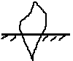 ***Use the diagram of a human tooth below and answer the questions that follow***.

10. How useful is the type of tooth above?

______________________________________________________________________________________________________________

11. Identify any one way in which trees are able to reduce air pollution in the environment.

______________________________________________________________________________________________________________

12. Why do most plants in desert areas have thorns?

_______________________________________________________

13. Name any one by product of respiration process.

_______________________________________________________

14. Which structures enable the trachea to remain open all the time?

_______________________________________________________

15. ***Study the diagram below and answer the questions that follow***.

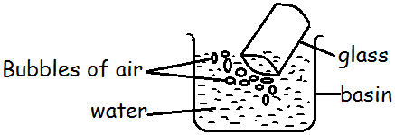

What does the experiment above prove?

______________________________________________________________________________________________________________

16. Why is the re-cycling an important process in the conservation of resource? _______________________________________________

_______________________________________________________

17. How is sun important in the process of rain cycle?

_______________________________________________________

_______________________________________________________

18. State the compass direction in which a freely suspended magnet will rest.

_______________________________________________________

19. How does the human body cool itself in a hot day?

_______________________________________________________

20. What health danger comes as a result of someone not completing his medical dose? ____________________________________________

_______________________________________________________

21. Name the type of mosquito that spread elephantiasis to humans.

_______________________________________________________

22. Why are ventilators put at a higher level above windows and doors in a house? _________________________________________________

_______________________________________________________

23. State one reason why a crop farmer should include beans in his crop rotation? ________________________________________________

_______________________________________________________

24. Give one major reason as to why one should wash his hands with soap after visiting a latrine. __________________________________________

_______________________________________________________

25. What do arachnids use for breathing?

_______________________________________________________

26. How does leaching reduce soil fertility?

______________________________________________________________________________________________________________

27. Name the type of blood cell which is affected by malaria parasites in the body.

_______________________________________________________

28. Give one use of water absorbed by seeds during germination.

______________________________________________________________________________________________________________

29. Why is it important for married couple to be treated together if they have got syphilis? _________________________________________

_______________________________________________________

30. How useful is frictional force to a P.7 candidate during his examinations?

_______________________________________________________

31. Name any one type of cattle kept by farmers in Uganda.

_______________________________________________________

32. Which disease is characterized by a sunken soft spot on a baby’s head (fontanelle)?

_______________________________________________________

33. Name the final digested food products from eating proteins to the body.

_______________________________________________________

34. Give one reason as to why water is not advisable to put out petrol fire.

______________________________________________________________________________________________________________

***Study the diagram of a flower and use it to answer the question about it***.

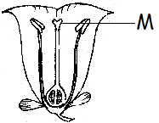

35. What is the use of the part marked “M” to a flower?

______________________________________________________________________________________________________________

36. Give one reason as to why filtrated water is not necessarily safe for drinking? ________________________________________________

_______________________________________________________

37. How useful is a stretcher when giving first aid?

_______________________________________________________

38. State any one characteristic of fruits and seeds dispersed by animals.

______________________________________________________________________________________________________________

39. Give any one reason as to why sugarcane is not considered as a stem tuber yet is stores food in its stem.

______________________________________________________________________________________________________________

40. Name any one diarrheal disease.

_______________________________________________________

***SECTION B***

41. (a) Give any one way in which Primary Health Care (PHC) is important to the community.

_______________________________________________________

(b) State the element of PHC which is promoted by each of the following activities.

(i) Cleaning water sources:

_______________________________________________________

(ii) Eating a balanced diet meal:

_______________________________________________________

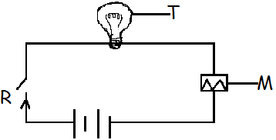42. ***Use the diagram below of a simple circuit to answer questions that follow***.

(a) How is the function of the part marked M similar to that of R?

______________________________________________________________________________________________________________

(b) Name the form of energy produced at part marked T when the circuit is completed.

_______________________________________________________

(c) Calculate the voltage used in the circuit above. (2mks)

43. (a) Give the difference between reflection and refraction.

______________________________________________________________________________________________________________

(b) Identify any two characteristics of image formed by plane mirrors.

i) ______________________________________________________

ii) _____________________________________________________

(c) How is reflection of light useful in our daily life?

______________________________________________________________________________________________________________

44. (a) What is respiration?

______________________________________________________________________________________________________________

(b) How are air sacs (Alveoli) adapted for gaseous exchange?

______________________________________________________________________________________________________________

(c) Give any one respiration disease caused by bacteria.

_______________________________________________________

(d) State any one way how one can maintain his respiratory system in good working condition. _________________________________________

_______________________________________________________

45. (a) What is immunity?

______________________________________________________________________________________________________________

(b) Study and complete the immunization table below.

|  |  |  |
| --- | --- | --- |
| **Disease** | **Vaccine** | **Immunization site** |
| Polio | Polio vaccine | i) |
| Tuberculosis | BCG | ii) |
| Diphtheria | iii) | Left upper thigh |

46. **An irregular object was lowered into an overflow can A containing water. The water it displaced was collected in container B as shown**.

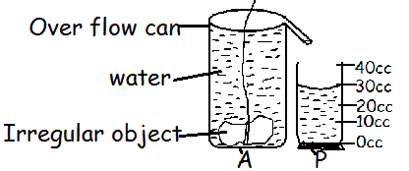

(a) What is the volume of the irregular object above?

(b) Calculate the density of the irregular object if its mass is 90g. (2mks)

(c) Name container marked P.

_______________________________________________________

47. (a) Which type of change takes place when an iron rusts?

_______________________________________________________

(b) Give two conditions necessary for rusting to take place on an iron tool.

i) ______________________________________________________

ii) _____________________________________________________

(c) State any one effect of rusting on iron tools.

_______________________________________________________

48. (a) What is environmental degradation?

______________________________________________________________________________________________________________

(b) Identify any two natural causes of environmental degradation.

i) ______________________________________________________

ii) _____________________________________________________

(c) Give any one human activity that cause environmental degradation.

_______________________________________________________

49. ***In the diagram below W,X and Y show the stages of germination of a seed. Study and use it to answer the questions that follow***.

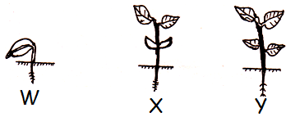

(a) Name the part marked Q.

_______________________________________________________

(b) How is part marked Q useful to the seedling at the stage marked X?

_______________________________________________________

(c) Why is the part marked Q useless at stage Y?

_______________________________________________________

(d) Which type of germination is shown by the above seeds?

_______________________________________________________

50. (a) Differentiate between poultry and poultry keeping.

______________________________________________________________________________________________________________

(b) Name any two vices in poultry which can be controlled by debeaking.

i) ______________________________________________________

ii) _____________________________________________________

(c) Give any one disease that attacks poultry.

_______________________________________________________

51. (a) What is the standard unit for measuring force?

_______________________________________________________

(b) A man weighs 60kg. He sits 1.5metres from the fulcrum (pivot) of a see-saw. How far from the fulcrum will a boy whose weight is 30kg, sit in order to balance up with the man in the see-saw. (3mks)

52. (a) What is the importance of a school garden to school children?

______________________________________________________

(b) Identify two factors to consider when choosing an area for a school garden.

i) ______________________________________________________

ii) _____________________________________________________

(c) Name any one framing practice that can be done in a school garden.

_______________________________________________________

53. (a) What is swarming? ______________________________________

_______________________________________________________

(b) Give two reasons as to why people keep bees.

i) ______________________________________________________

ii) _____________________________________________________

(c) State any one way how bees can be dangerous to human beings.

______________________________________________________________________________________________________________

54. (a) What is the difference between transparent and translucent objects?

_____________________________________________________________________________________________________________________________________________________________________

(b) Give any one example of opaque object.

_______________________________________________________

(c) Name the type of lens used to correct long sightedness.

_______________________________________________________

(d) Which part of the eye has the same function as film in the lens camera?

_______________________________________________________

55. (a) Give the difference between a predator and a scavenger.

_____________________________________________________________________________________________________________________________________________________________________

(b) In which way are scavengers useful in the environment?

______________________________________________________________________________________________________________

(c) Name any two examples of scavenger birds.

i) ______________________________________________________

ii) _____________________________________________________